

**GEOGRAPHY 273/1**

**SENIOR FOUR**

**TIME: 2 HOURS**

**Instructions:**

Attempt any three items

**ITEM 1**.According to the 2021 Uganda Population Survey, the country’s population was estimated to be 42 million, and growing at a rate of 3 % per year.

At this rate, the country’s population is expected to reach 72.4 million people by 2040; representing an annual increase of 1.6 million people per year.

Members of your community have different views about this rate of population growth. Some see it as a benefit, while others think it is a danger to the country

**Support material**

The table showing total population of Uganda between 1980 and 2010

|  |  |
| --- | --- |
| Year | Total population in 000000s |
| 1980 | 126 |
| 1985 | 162 |
| 1990 | 242 |
| 1995 | 346 |
| 2000 | 486 |
| 2005 | 540 |
| 2010 | 600 |

**Tasks**

(a) Draw a suitable graph to show the information in the table. (7marks)

(b) Using the information provided in the text and table, write an article of between **250 – 300** to be published in one of the local newspapers that will help you deal with the concerns of the members of your community (13 marks)

**ITEM** 2. The government has discovered minerals in your area and it wants to start the extraction and establish a processing industry. However, the people who have lived in the area are against the government project because their land is a source of their livelihood in terms of agriculture, hunting and food gathering, wood products, settlement and fishing. The members of the community are mobilizing themselves to fail government efforts in all ways. The government officials have been asked to meet with the members of the community to find a way of how to sensitize them about the government project.

**Support:**

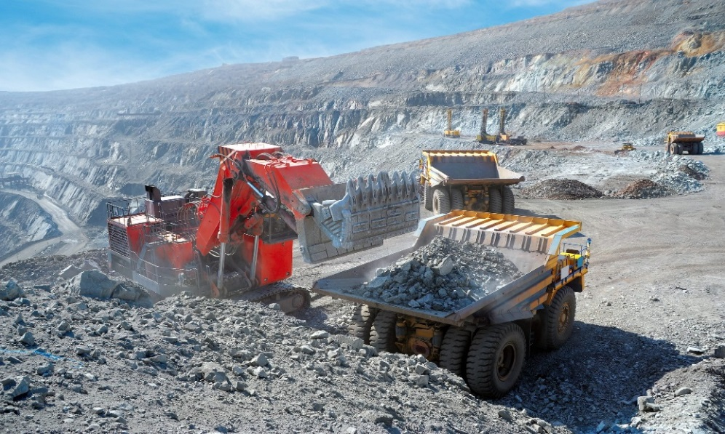

**Task:**

1. With the help of a diagram, describe the method that is used in mining the mineral as shown above in the table. (10 marks)
2. Write a detailed information convincing the community about the goodness of the project such that they can support the government to continue with the project from the above scenario. (10 marks)

**ITEM 3**. One of your family members is migrating from villages and he is planning to move out of the country and settle in one of the major cities in Africa. Some the major cities of Africa include Lagos of Nigeria and Johannesburg of south Africa. This is because he has realized the major functions of urban centers.

**Tasks**

1. Write a detailed information as to why Sarah should go and settle in either Lagos or Johannesburg (10marks)
2. According to you what are some of the dangers that Sarah is likely to be facing while staying in either Lagos or Johannesburg. (10marks)

**ITEM 4**. Forestry is one of the major activities taking place in the tropical country Gabon. Gabon is found in Africa with a variety of tropical rain forests. It is one of the major activities in Gabon. Some people look at the sector as a danger and others look at it as a blessing to the country.

**Support material**

The table showing different tree species in Gabon.

|  |  |
| --- | --- |
| Tree species | Percentage of trees (%) |
| Ebony | 30 |
| Mahogany | 20 |
| Red heart | 15 |
| Mvule | 10 |
| Green heart | 13 |
| Rose wood | 12 |

**Tasks**

1. Draw a pie chart to showing various tree species in Gabon. (10marks)
2. Write a detailed information showing how the sector is a blessing to the country or a danger. (10marks)

**END**